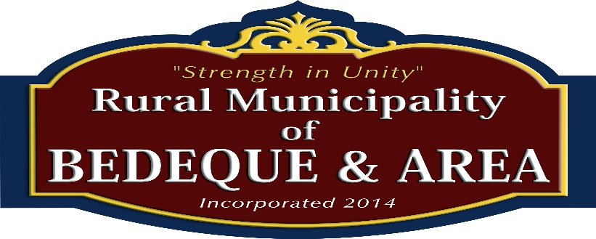

Annual Budget Meeting-Minutes

Thursday, March 21st, 2024 @ 7:00 pm

CDC Boardroom, William Callbeck Centre

**Present: Absent:**

**Mayor:** Matthew Bowness

**Councillors: Councillors:**

Karen Ashley-Neill (Deputy Mayor) Mitchell Arsenault

Nichola Arsenault

Derrick Blacquiere

Robert Green

Barry Stewart

**CAO:** Kevin McKenna

1. **Call to Order and Attendance –** Meeting was called to order at 7:00 PM. Mayor Matthew Bowness welcomed all Councillors and Guests in attendance.
2. **Approval of Agenda:**  Moved by Nichola Arsenault, seconded by Barry Stewart that the agenda be approved as presented. **Motion Carried**.
3. **Budget Presentation:** The Financial Plan (**Attached to these Minutes**) was presented to Council and all public guests present. The 2024-2025 Fiscal Year Budget projected a slight operating surplus of $ 55.00. As a result, the Municipal Tax Rate remained the same as last fiscal year at 30 cents per $ 100.00 of Assessed Values. Therefore, no increases in Municipal Taxes are projected for this upcoming fiscal year.
4. **Approval of Financial Plan 2024-2025 Fiscal:**  Moved by Barry Stewart, seconded by Derrick Blacquiere that the 2024-2025 Fiscal Year Financial Plan be approved as presented. **Motion Carried**.
5. **Open Floor:**
6. **Insurance On Water Pump Shed Generator:** Council discussed the requirement to add insurance coverage on this Generator even while it is being stored in Councillor Rob Green’s warehouse and after it will be installed at the Water Pump location. CAO Kevin is to contact Cooke Insurance tomorrow and add insurance coverage on the generator under our existing policy. A quote had been received from Cooke Insurance for an additional premium of $148.00 per year.
7. **Memorandum of Understanding for Warming Center – RMBAA and Baptist Church:**

Council felt that a meeting be arranged with the Bedeque Baptist Church representatives and a few members from our Council to hash out who is responsible for what expenditures and responsibilities and get these outlined on an Appendix to our present Memorandum of Understanding. CAO Kevin will arrange for this meeting.

1. **Memorandum of Understanding for Water Pump Shed Generator – Kinkora Fire Department**.

Councillor Barry Stewart had mentioned in his discussions with Chief Jonnie Dougay, Kinkora Fire Department that they might take care of refilling the propane tanks. An additional meeting should be setup with the Kinkora Fire Department to determine upkeep and maintenance schedules and who is responsible. Again a Memorandum of Understanding should be established between both parties to reflect these responsibilities.

1. **Schedule Next Regular Council Meeting Date:** May 2nd, 2024 @ 7:00 PM
2. **Adjournment:** Moved by Rob Green that the meeting be adjourned at 7:40 PM

-------------------------------------------------- ------------------------------------------------------

Prepared By: CAO, Kevin P. McKenna Approved By: Mayor: Matthew Bowness